**Lab 5**

Census Data Application

**Deliverables:**

1. Questions: 1-6
2. Graphics: 1-3

**QUESTION 1: Which CBSAs have the most counties within their composition? List the top 5 and the number of counties each.** (HINT: Look at join_count)

1. San Juan-Carolina-Caguas: 40
2. Atlanta-Sandy Springs-Roswell: 29
3. New York-Newark-Jersey City: 25
4. Washington-Arlington-Alexandria: 24
5. Richmond: 17

**QUESTION 2: What two CBSAs have the smallest percentage of area that is considered urban area (UAs)? What two MSAs have the largest percentage of area that is considered urban area?**

Smallest Percentage of Urban Area:

* Ketchikan, AK: 0.084%
* Jackson, WY-ID: 0.088%

Largest Percentage of Urban Area:

* Trenton, NJ: 58.861%
* Bridgeport-Stamford-Norwalk, CT: 54.293%

**QUESTION 3: Which state geographies’ FIPS codes start with ‘12’? (HINT: look at GEOID and STATEFP in the counties layer, also google “State FIPS” to understand/learn more)**

Florida

**QUESTION 4: What does it mean to be housing insecure?**

Housing insecurity is the lack of security in an individual shelter that is the result of high housing costs relative to income, poor housing quality, unstable neighborhoods, overcrowding, and/or homelessness.

**QUESTION 5: What is the rate of housing insecurity in the top 5 tracts, what is the count (Hsins)?**

|  |  |
| --- | --- |
| **Rate (%)** | **Count** |
| 0.585 | 18720.585 |
| 0.478 | 968 |
| 0.404 | 279 |
| 0.374 | 669 |
| 0.321 | 496 |

**QUESTION 6: Where are these households located? What sort of explanation might make sense for this clustering?**

These households are located in Downtown Eugene, or near Campus. This could be for a number of reasons. There are multiple high-rise buildings for low-income families located downtown. Downtown is also the city center, so housing in this area is likely costlier overall. Housing costs are also much higher near UO.

**GRAPHIC 1: Make a map showing the difference between counties, CBSAs and UAs in an area of your choice. Imagine that your goal is to educate someone about the different classification categories.**

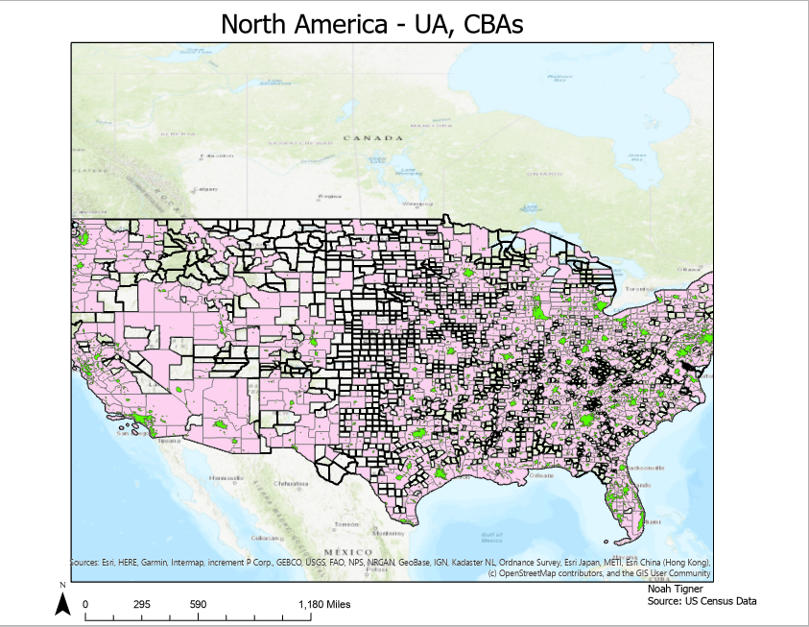

**GRAPHIC 2: Make a diagram of the steps that you followed to do these analyses. You should have two diagrams - the first for steps 1-12 and the second for steps 13-21. Make sure to include your input and output data sources and the tools run.**

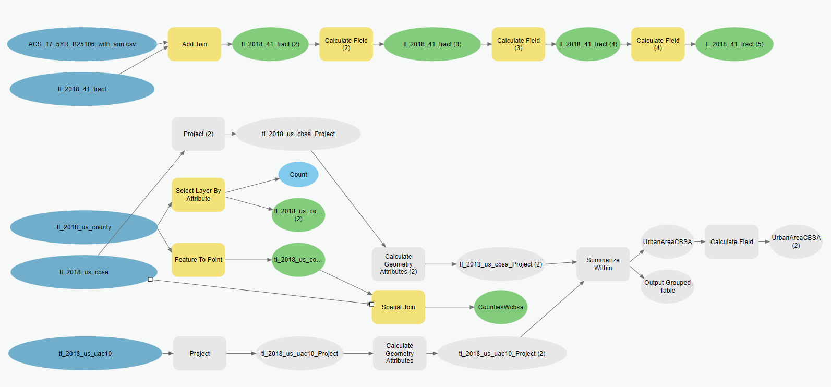

**GRAPHIC 3: Make a nice map of housing insecurity that tells a story. Be creative! Do you want to show spatial patterns in rates or counts? Do you want to highlight areas with higher rates? Think about the story that you want to tell and tailor your visualization to that.**

